GST Rejected Credit Note Downloader
- Authentication:
- Enter registered email id: shabanamulla@cnkindia.com
- It will get an OTP on your email, you need to enter it in the application
- How to use the application:
- Select Client Login Excel File
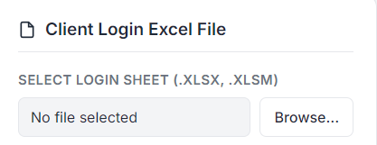
- Select Download Directory – select a folder where you want to save the output. The application will create a folder structure: client name/state/month/it will save the rejected entries in Excel here.
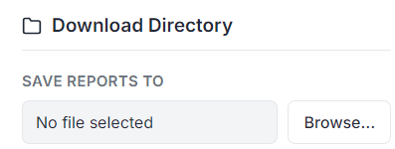
- Portal form:
- Select financial year. It will collect all data between the selected financial years for processing. (choose from the drop-down menu).
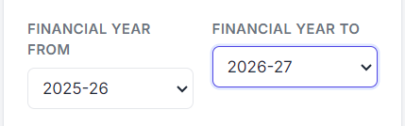
- Select the return period. It will collect all data between from and to period (choose from the drop-down menu)
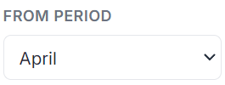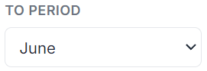
- Select file option (choose from the drop-down menu)
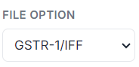
- It is for browser screen size; you can choose it from the drop-down menu. Default 85%.
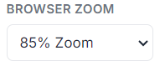
- Example: If From Financial Year is selected as FY 2025–26, To Financial Year is selected as FY 2026–27, and the Return Period is selected from April to June, the application will automatically collect data for April 2025 through June 2026, including all months within the selected range (April 2025 to June 2026).

- After filing the form, click on this button


- Client login preview refers to the list of clients we have in our input file.
- Selected numbers represent those clients we are going to search for
- Completed numbers represent those clients for whom we have already collected data (status will be saved in your input login file automatically)
- Failed numbers represent those clients which we encountered an error while searching.
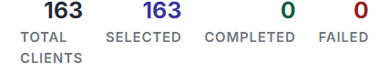
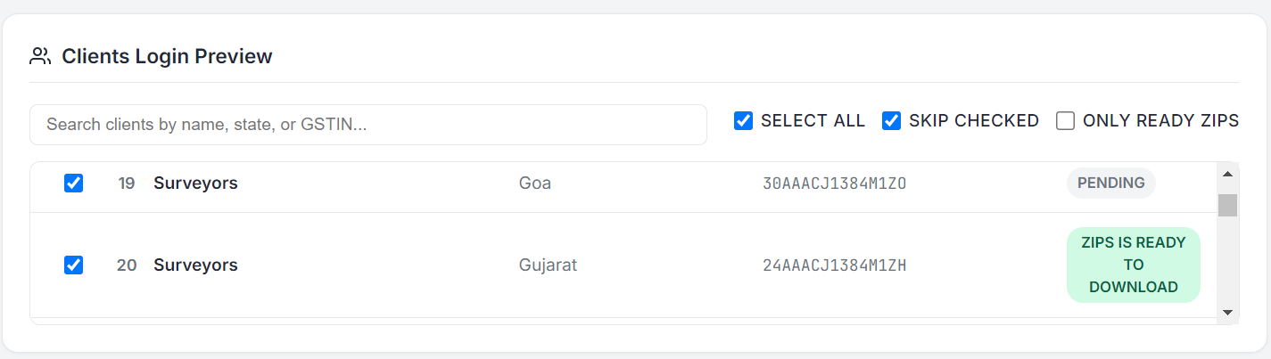
- Select all means we have selected all the clients in input file
- Skip check will skip that user which we have already checked (which status are success in our input file).
For example, if we stop the work and want to continue it later that time skip checked will be useful.
- Next time before uploading login file you have to clear the history by simply deleting status column form input login file .
- If you want to search for specific client you can untick both select all and skip checked, then select the user manually from the client login preview.
- Some clients rejected reports are not available and requested to send the request, and it will take 20 minutes. So the software saves the request and alerts you when it’s ready to download.
- Only a ready zip will help you download the requested rejected invoices/ credit notes.
- Click on the start button to run the automation
- You just need to enter the captcha rest of the things are done automatically.
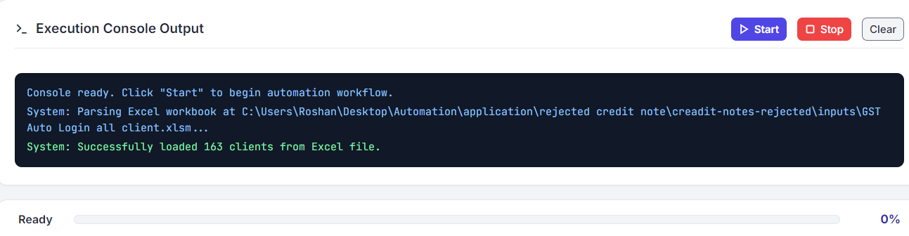
If you want to stop the automation, just click on the stop button.
The exception console will show the progress.
- An Excel report will be generated.
- Consolidator Report Generator:
After you download all the rejected notes, you can select Report Consolidator on the top bar.
i) Select the output folder with rejected notes
ii) Click on the “Consolidate Reports” button.

After clicking the Consolidated Report button, the application will generate both of the following consolidated Excel files:

- Client-wise Consolidated Report
- State-wise Consolidated Report

Both reports will be automatically created and saved in their respective folders within the selected output directory.
The output will be stored in [ Client

State wise consolidated file
Client name/state/Consolidated/Consolidated_Rejected_Notes.xlsx] for each state of client it will get created.

Client Wise consolidated File
Client name/Client Wise Consolidation/Client_Wise_Consolidated for each client it will get created.

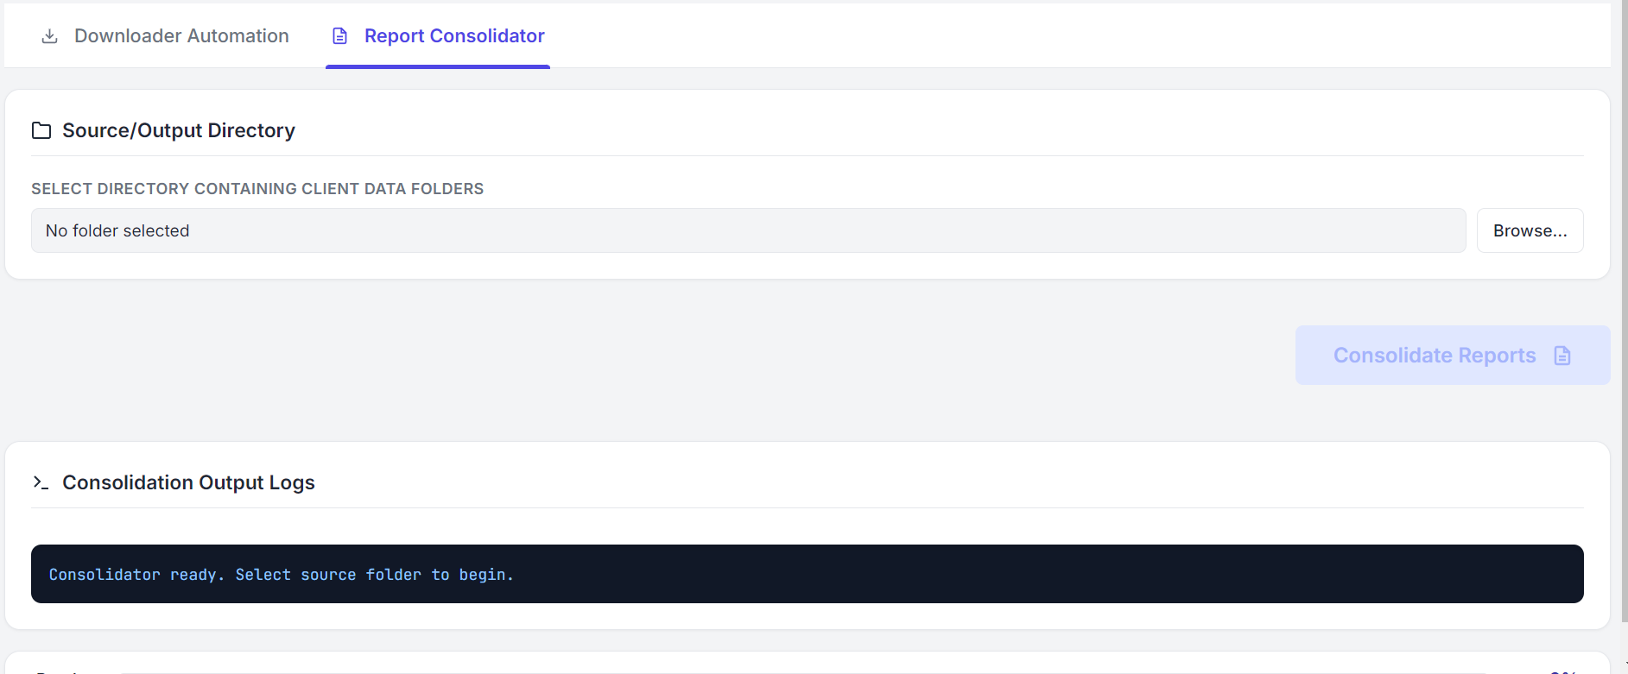
- Click on the logout button after the work is done


